Student Name: __________________
Class and Section __________________
Total Points (20 pts) __________________
Due: September 7, 2016 before the class

Project: 24-Point Card Game

CSCI 2410 Data Structures and Algorithms
Armstrong Atlantic State University

Team Project: Form a team with 2 or 3 members. Each member needs to submit it online. Submit one hard copy for the team.

Team members: ________________________

Problem Description:

The 24-point game is to pick any four cards from 52 cards, as shown in the figure below. Note that two Jokers are excluded. Each card represents a number. An Ace, King, Queen, and Jack represent 1, 13, 12, and 11, respectively. Enter an expression that uses the four numbers from the four selected cards. Each number must be used once and only once. You can use the operators (addition, subtraction, multiplication, and division) and parentheses in the expression. The expression must evaluate to 24. After entering the expression, click the Verify button to check whether the numbers in the expression are currently selected and whether the result of the expression is correct. Display the verification in a dialog box. Note that such an expression might not exist. In this case, click the Refresh button to get another set of four cards. Assume that images are stored in files named 1.png, 2.png, ..., 52.png, in the order of spades, hearts, diamonds, and clubs. So, the first 13 images are for spades 1, 2, 3, ..., and 13.

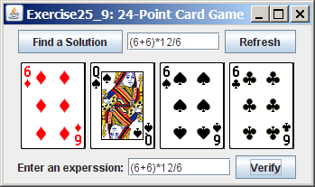

Your program should also enable the computer to display the expression if one exists, as shown in the figure. Otherwise, report that the expression does not exist.

Reference for this project: Listing 6.2, Exercise 12.9, and Listing 25.11.

Design:

Draw the UML diagrams of the classes used in your project.

Coding:

Name your main class Exercise22_15.

Testing:

Describe how you test your project.

Screen shots.

At least four screen shots to demonstrate your program.

Self-Evaluations:

- Can your program display the UI correctly? ____________
- Can your program display four cards randomly? ____________
- Can your program verify a user-entered expression for 24 points? _________
- Can your program automatically find a solution or report no solution? _________

What to submit?

1. Print and turn in this document (one for the team).

2. (for each team member) Compile and Submit to LiveLab (you must submit the program regardless whether it is complete or incomplete, correct or incorrect)

